**AI-powered classification of the diabetic retinopathy severity**

**Prepared by**

Thanh Thao Nguyen ([nguyen53661@saskpolytech.ca](mailto:nguyen53661@saskpolytech.ca))

**Under the guidance of**

The Artificial Intelligence and Data Analytics Program

**Submitted to**

Himanshu Patel ([patelh@saskpolytech.ca](mailto:patelh@saskpolytech.ca))

**Saskatchewan Polytechnic**



**CAPSTONE PROJECT REPORT**

**OCTOBER 2025**

**ABSTRACT**

This project aims to develop a deep learning model for diabetic retinopathy severity classification using **EfficientNet**. The model processes high-resolution retinal images to classify diabetic retinopathy accurately. The dataset used is sourced from Kaggle's Diabetic Retinopathy 224x224 (2019 Data) dataset, containing 3,663 images and their corresponding masks. The report details the methodology, data preprocessing steps, model training, evaluation, and comparisons between EfficientNet and ResNet.

**ACKNOWLEDGEMENT**

We extend our gratitude to our faculty mentor, Himanshu Patel, for the guidance and support throughout this project. We also thank Saskatchewan Polytechnic for providing the necessary resources and infrastructure for our research. Finally, we appreciate the contributions of online communities, particularly Kaggle, for dataset availability and valuable insights.

**TABLE OF CONTENTS**

Contents

**I.** **INTRODUCTION** 5

**II.** **PROJECT OVERVIEW** 5

**III.** **PROBLEM STATEMENT** 5

**IV.** **PROJECT OBJECTIVE** 5

**V.** **RELATED WORK** 6

**VI.** **METHODOLOGY** 6

1. Data Collection 6

2. Data Preprocessing 6

3. Model Development 6

4. Evaluation 6

5. Ethical Consideration 7

**VII.** **IMPLEMENTATION PROGRESS** 7

**VIII.** **RESULTS AND ANALYSIS** 9

**IX.** **CONCLUSION** 9

**X.** **SCOPE OF FUTURE WORK** 9

**XI.** **REFERENCES** 9

# **INTRODUCTION**

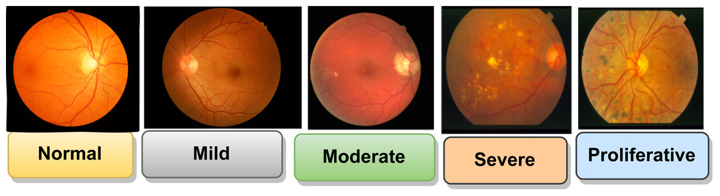

**The severity of Diabetic Retinopathy ranges from Normal to Proliferative**

With the rise of artificial intelligence and deep learning in health care applications, rapid and accurate diabetic retinopathy classification via retinal images has become a crucial task for personal treatment planning, patients’ physical and mental health care, and cost-saving. Traditional methods for diabetic retinopathy classification often struggle with the complexity of the disease, the ability of doctors, and the personal situation of each patient. This project trains an EfficientNet model to enhance diabetic retinopathy classification accuracy, and compares it with ResNet.

# **PROJECT OVERVIEW**

This project implements and evaluates EfficientNet for diabetic retinopathy classification via retinal images. The key objectives include:

* Utilizing EfficientNet's advanced features to classify retinal images effectively.
* Evaluating performance based on testing a real retinal image.
* Comparing results with ResNet to assess the best-performing model.

# **PROBLEM STATEMENT**

Accurately classifying diabetic retinopathy via retinal image is a challenging task due to various factors, such as the misclassification of retinal images and the personal situation of each patient. Traditional classification based on doctors is time-consuming, necessitating an automated deep learning-based approach.

# **PROJECT OBJECTIVE**

* Implement EfficientNet for precise diabetic retinopathy classification.
* Enhance classification accuracy using optimized preprocessing techniques.
* Compare performance metrics with ResNet to determine effectiveness.
* Generate reliable classification outputs for real-world applications.

# **RELATED WORK**

Previous research in diabetic retinopathy classification applies a computer vision technique and a deep learning model named EyeArt (owned by the company named Eyenuk, Inc.). The limitation of this model is misclassifies “healthy” eyes as “diabetic retinopathy” eyes - misclassification. The EfficientNet model improves classification accuracy and avoids misclassification.

# **METHODOLOGY**

## Data Collection

The dataset is sourced from Kaggle’s Diabetic Retinopathy 224x224 (2019 Data) dataset, containing 3,663 high-resolution images and their corresponding masks.

The link to the dataset is [Diabetic Retinopathy 224x224 (2019 Data)](https://www.kaggle.com/datasets/sovitrath/diabetic-retinopathy-224x224-2019-data)

## Data Preprocessing

* **Normalization**: Standardized pixel values for uniform processing (224x224 pixel)
* **Augmentation**: Applied horizontal flip, rotation, zoom, and contrast to increase data diversity.

## Model Development

* **Architecture**: EfficientNet (main) and ResNet
* **Loss Function**: sparse_categorical_crossentropy
* **Optimizer**: Adam optimizer with a learning rate of 0.00001
* **Metrics**: Precision, Recall, F1-score, Accuracy and Confusion Matrix for performance evaluation

## Evaluation

The EfficientNetV2B3 model was trained for 10 epochs on a CPU-enabled environment and evaluated on a validation dataset.

* **Accuracy:** 59.89%
* **Loss:** 96.56%

The accuracy is low. The model needs to be trained more.

## Ethical Consideration

* + **Data Bias**: The dataset was analyzed for geographic and structural biases.
  + **Privacy Concerns**: Satellite imagery was sourced from open-access datasets.

# **IMPLEMENTATION PROGRESS**

* **Week [1] (Date Range: 26th September to 3rd October):**

Import the libraries into Google Colab.

Upload the dataset of diabetic retinopathy by using the API.

Handle missing values, label, and resize images.

* **Week [2] (Date Range: 3rd October to 10th October):**

Split the dataset into train, validation, and test sets.

Training the EfficientNetB0 model.

* **Week [3] (Date Range: 10th October to 17th October):**

Continue to train the EfficientNetB0 model.

* **Week [4] (Date Range: 17th October to 24th October):**

Change to use the EfficientNetV2B3 model.

Train the ResNet50 model.

Compare the results of two models.

The workflow is as follows for your reference.

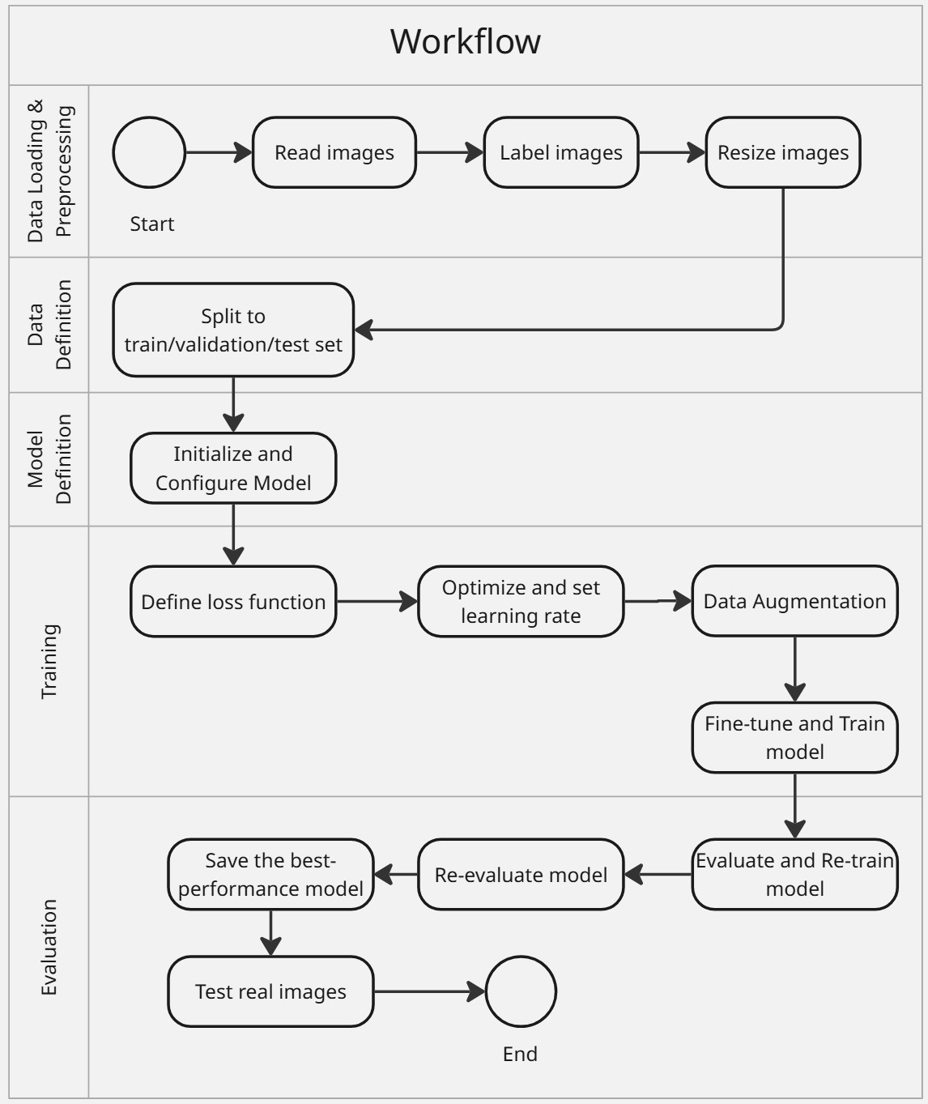

# **RESULTS AND ANALYSIS**

* **Accuracy Comparison:**

EfficientNetV2B3: 59.89%

ResNet50: 73.67%

* **Loss Comparison:**

EfficientNetV2B3: 96.56%

ResNet50: 70.42%

* **Model Preference:**

ResNet50 is a preferred model.

# **CONCLUSION**

EfficientNetV2B3 gets a low accuracy of 59.89%. ResNet50 performs well in terms of accuracy of 73.67%. So, ResNet50 is preferred in real-time situations.

# **SCOPE OF FUTURE WORK**

* Training the DenseNet and Vision Transformer models.
* Expanding the dataset to include diverse retinal images.
* Deploying the best model in real-world applications.

# **REFERENCES**

**Jennifer Irene Lim, Carl D Regillo, SriniVas R Sadda, Eli Ipp, Malavika Bhaskaranand, Chaithanya Ramachandra, Kaushal Solanki** (30th September 2022), Artificial Intelligence Detection of Diabetic Retinopathy. *Ophthalmol Sci,* 3(1):100228. <https://pmc.ncbi.nlm.nih.gov/articles/PMC9636573/>